Assignment 3

**Question:** Write a JAVA program to implement a class BoardParam with data members len, width and area. Implement a constructor to initialize the data members, a function calcArea to calculate the area.

**Code:**

import java.util.*;

class BoardParam

{

double len, width, area;

BoardParam(double x, double y)

{

len = x;

width = y;

}

void CalcArea()

{

area = len * width;

}

void display()

{

System.out.println("Area = "+area);

}

}

class Test

{

public static void main(String[] args)

{

Scanner sc = new Scanner(System.in);

double x, y;

System.out.println("Enter the length");

x = sc.nextDouble();

System.out.println("Enter the width");

y = sc.nextDouble();

BoardParam obj = new BoardParam(x, y);

obj.CalcArea();

obj.display();

}

}

**Output:**

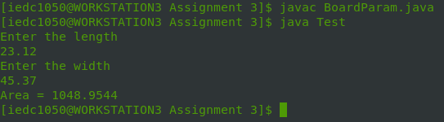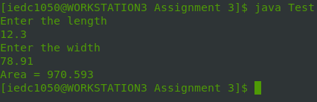

**Question:** Write a program to implement a class Shape with triangle, rectangle and circle as objects. Calculate the area of these shapes using the concept of function overloading.

**Code:**

import java.util.*;

class Shape

{

double calcArea(double radius)

{

return Math.PI * radius * radius;

}

double calcArea(double a, double b, double c)

{

double s = (a + b + c) / 2;

return Math.sqrt(s * (s - a) * (s - b) * (s - c));

}

double calcArea(double length, double breadth)

{

return length * breadth;

}

}

class Test

{

public static void main(String[] args)

{

System.out.println("1-Circle\n2-Triangle\n3-Rectangle");

System.out.println("Input choice");

Scanner sc = new Scanner(System.in);

int ch = sc.nextInt();

switch (ch)

{

case 1: System.out.println("Enter radius");

double radius = sc.nextDouble();

Shape circle = new Shape();

System.out.println("Area = "+circle.calcArea(radius));

break;

case 2: System.out.println("Enter the length of the three sides");

double a = sc.nextDouble();

double b = sc.nextDouble();

double c = sc.nextDouble();

Shape triangle = new Shape();

System.out.println("Area = "+triangle.calcArea(a, b, c));

break;

case 3: System.out.println("Enter the length and breadth");

double a1 = sc.nextDouble();

double b1 = sc.nextDouble();

Shape rectangle = new Shape();

System.out.println("Area = "+rectangle.calcArea(a1, b1));

break;

default:

break;

}

}

}

**Output:**

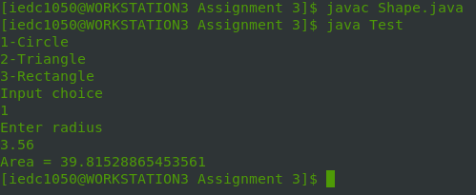

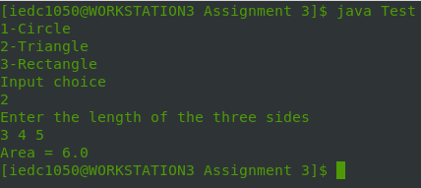

**Question:** Write a program to implement a Matrix class and add two matrices

**Code:**

import java.util.*;

class Matrix

{

int rows, cols;

double arr[][];

Matrix(int x, int y)

{

rows = x;

cols = y;

arr = new double[rows][cols];

}

void input()

{

for(int i = 0; i < rows; i++)

for(int j = 0; j< cols; j++)

arr[i][j] = new Scanner(System.in).nextDouble();

}

void add(Matrix obj)

{

for(int i = 0; i < rows; i++)

for(int j = 0; j < cols; j++)

arr[i][j] += obj.arr[i][j];

}

void display()

{

for(int i = 0; i < rows; i++)

{

for(int j = 0; j < cols; j++)

System.out.print(arr[i][j]+"\t");

System.out.println();

}

}

}

class Test

{

public static void main(String[] args)

{

int x, y;

System.out.println("Enter the number of rows and columns");

Scanner sc = new Scanner(System.in);

x = sc.nextInt();

y = sc.nextInt();

Matrix obj = new Matrix(x, y);

Matrix obj1 = new Matrix(x, y);

System.out.println("Enter the first matrix");

obj.input();

System.out.println("Enter the second matrix");

obj1.input();

obj.add(obj1);

System.out.println("The answer is:");

obj.display();

}

}

**Output:**

